**New Batch Code Logic**

Taki Guan

# Version History

|  |  |  |  |
| --- | --- | --- | --- |
| Version | Author | Date | Changes |
| 1.0 | Taki Guan | 2019-3-19 | Create Document |
| 1.0 | Taki Guan | 2019-3-21 | Modify Document |
| 1.0 | Taki Guan | 2019-3-21 | Finish Document |
|  |  |  |  |
|  |  |  |  |
|  |  |  |  |

Contents

Version History 1

Purpose 1

Procedure 1

Architecture 3

Reference Link 6

# Purpose

This file is to describe how to generate new batch code in OPERA.

This file will help other developers to find the store procedure and batch code generation logic.

# Procedure

Currently, Colgate Sanxiao is using Code Date on Shipper in format DDMMYYCN1551, which includes 12 characters.

Current code date: DDMMYYCN1551.

- DD: Date

- MM: Month

- Year (2 last digits of year)

- CN15: Colgate Sanxiao in SAP

- S: Shift (A, B, C; 1, 2, 3)

- L: Line (A-Z; a-z; 0-9)

Starting from Q1, 2015, Colgate Sanxiao will implement WMS (Warehouse Management System) for Finished Goods. Based on SAP system, Code date format is limited in 10 characters. So, we could not adapt current format in SAP.

To align between code dates on shipper, packaging lot, COA, pallet and code date in SAP system, we propose to change new format as below:

New code date: DDMMYYXSLL

- DD: Date

- MM: Month

- YY: Year (2 last digits of year)

- X: Colgate Sanxiao in SAP

- S: Shift (A, B, C)

- LL: Line (01-99)

But after WIP execution, the batch code logic has been changed as below.

|  |  |  |
| --- | --- | --- |
| **WIP Process** | **After QM** | **Remark** |
| Injection process | JJJY**LLLLLL**(10 digitals) | 8 digitals before QM to 10 digitals after QM |
| **LLLLLL**- Machine number |
|  |
| T&E process | JJJY**SLLLLL**(10 digitals) | Set up a link of date code on TB neck with system |
| **S**- D/E/F for CSX |
| **LLLLL**- Machine number |
| PK process | **DDMMYYXSLL**(10 digitals) | SX Plant code change from 15 to X; |
| **S**- A/B/C for CSX | Line # change from letter to two digital number |

Line number can be export from SAP ZPOTEXT table use T-Code ZSE16. OPERA production line number is listed as below.

|  |  |
| --- | --- |
| Actual Line | Production Line |
| P2HA6015 | 29 |
| T2BH0201 | 10088 |
| T2BH0202 | 10095 |
| T2BH0203 | 10096 |
| T2BH0204 | 10097 |
| T2BH0205 | 10098 |
| T2BH0206 | 10089 |
| T2BH0207 | 10101 |
| T2BH0208 | 10099 |
| T2BH0209 | 10100 |
| T2BH0210 | 10130 |
| H2FCS501 | 000564 |
| H2FCS502 | 000566 |
| H2FCS503 | 000567 |
| H2FCS601 | 000539 |
| H2FCS602 | 000557 |
| H2FCS603 | 000559 |
| H2FCS604 | 000561 |
| H2FCS901 | 000535 |
| H2FCS902 | 000540 |
| H2FCS903 | 000555 |
| H2FCS904 | 000556 |
| H2FCS951 | 000538 |
| H2FCS952 | 000518 |
| H2FCS953 | 000235 |
| H2FCS954 | 000236 |

We can configure line ID use MES configurator. Actually we can use admin tool go to line configuration, I think configurator will be quicker and more accurate.

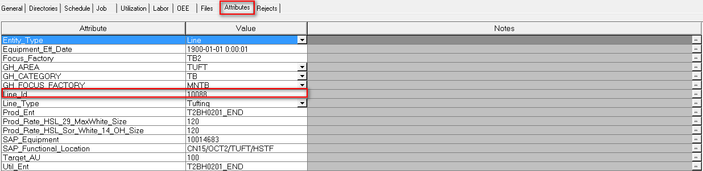

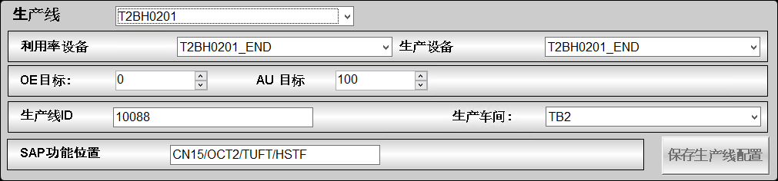

# Architecture

Set [Cfg.SAPShiftMode.Desc] with 5 elements for template [$ngsfrLine] and [$ngsfrLineExt]:

|  |
| --- |
| 1. SAPShift same as OPERA  2. SAPShift different than OPERA  3. Special logic for packaging line at Sanxiao  4. Special logic for tufting line at Sanxiao  5. Special logic for injection line at Sanxiao |

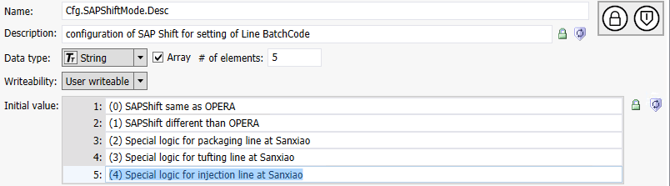

Update the [Script.GetShiftData] for template [$ngsfrLine] and [$ngsfrLineExt] to create batch code based on [Cfg.SAPShiftMode].

'added by Yahua on 2018-10-25 for sanxiao

if Me.Cfg.SAPShiftMode<2 then

'original script

Y = StringRight(ShiftStart.ToString("%y"),1);

'DOUBLE CHECK!!!

Dim myCal As System.Globalization.GregorianCalendar;

myCal = New System.Globalization.GregorianCalendar();

JJJ = StringRight("00" + myCal.GetDayOfYear(ShiftStart), 3);

PPPP = Me.PlantCode;

L = Me.LineID;

Me.BatchCode = Y + JJJ + PPPP + S + L;

If Me.Debug == True Then

LogMessage("BATCHCODE = " + Me.BatchCode);

LogMessage("Y = " + Y);

LogMessage("JJJ = " + JJJ);

LogMessage("S = " + S);

LogMessage("L = " + L);

LogMessage("Me.Shift.QualityShiftStartLocal = " + Me.Shift.QualityShiftStartLocal);

LogMessage("Me.Shift.QualityShiftEndLocal = " + Me.Shift.QualityShiftEndLocal);

EndIf;

elseif Me.Cfg.SAPShiftMode==2 then

JJJ=System.String.Format("{0:ddMMyy}",ShiftStart);

if S=="1" then

S="A";

elseif S=="2" then

S="B";

else

S="C";

endif;

L=Me.LineID;

Me.BatchCode=JJJ+"X"+S+L;

'for packing line

elseif Me.Cfg.SAPShiftMode==3 then

'for injection line and tufting line

'Taki update injection line logic on 2019-03-21, now below logic is only work for tufting

Y = StringRight(ShiftStart.ToString("%y"),1);

Dim myCal1 As System.Globalization.GregorianCalendar;

myCal1 = New System.Globalization.GregorianCalendar();

JJJ = StringRight("00" + myCal1.GetDayOfYear(ShiftStart), 3);

if S=="1" then

S="D";

elseif S=="2" then

S="E";

else

S="F";

endif;

L=Me.LineID;

Me.BatchCode=JJJ+Y+S+L;

elseif Me.Cfg.SAPShiftMode == 4 then

' Taki add Injection batch code calculation logic on 2019-03-21

Y = StringRight(ShiftStart.ToString("%y"),1);

Dim myCal1 As System.Globalization.GregorianCalendar;

myCal1 = New System.Globalization.GregorianCalendar();

JJJ = StringRight("00" + myCal1.GetDayOfYear(ShiftStart), 3);

L = Me.LineID;

Me.BatchCode=JJJ+Y+L;

else

Me.BatchCode="";

endif;

We need manually change [Cfg.SAPShiftMode] for specific line type.

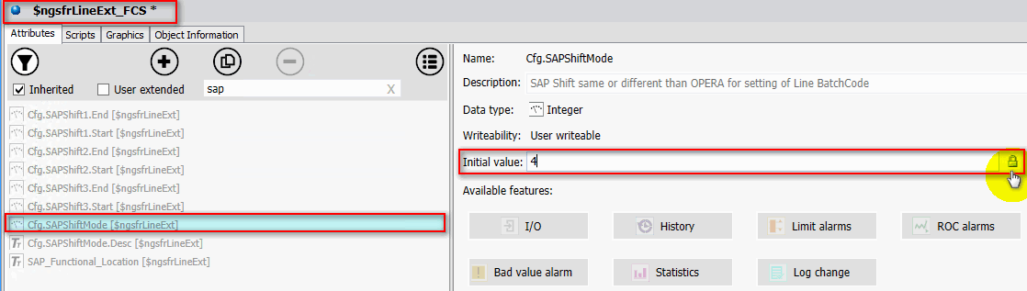

# Reference Link

1. [Line ID Data Exported from SAP](https://drive.google.com/open?id=1zC109leoi7iEpG_NzbacGW2hJqAZXKNH)